***Work on Analytics for Reality Models***

***A Report to the CEO***

***By***

***Shantanu Singh***

***(Student ID – 3071630)***

***MANP007 – Digital Business & Data Technologies***

**Date: 29th March 2022**

**Word Count - 2220**

# **Executive Summary:**

This report is created for the evaluation of the business and sales of Reality Models and the appropriate use of digital technologies for the improvement of their business. Analysis of appropriate B2B business sales websites using Google analytics for that company considered and discussed with details for this report. For the development of the business sales, the sales data of that company have been analyzed here using Power BI software. This data should be used to provide an accurate appraisal of the business situation. These evaluations are advantageous to enterprises. If these businesses and sales sites could be linked together, the corporation may be successful in its own industry.

Google Analytics should be used effectively for evaluating customer behavior and product performance. Google Analytics' analytical methodologies are critical for gaining a comprehensive picture of a website and assessing a company's business status. These evaluations are advantageous to enterprises. If these businesses and sales sites could be linked together, the corporation may be successful in its own industry.

For the successful growth of various business components, several business assessments and management techniques are important. The organization should employ adequate strategy frameworks for the development of its business and related sales in the next years. There is also a recommendation about appropriate technological implementation for the company's future business models, which will improve their business.

# **Table of Contents**

Introduction 3

Description of Business Situation 4

Methodology 4

Marketing Methodology Used 4

Business Analytics Methodology Used 4

Assessment of Current Situation 5

How a B2B Sales Site and Google Analytics can Help Reality Models 5

Conversion analysis using Google Analytics 5

Key audience attributes 7

How Power BI and Sales Data Can be used Alongside Google Analytics 8

Recommendations of Digital Technologies to be used by RealityModels in Years to Come 12

Conclusions 13

References 13

# **Introduction:**

In this analytical report, the significance of B2B (business to business) sites for sales and Google analytics would be evaluated for the business development of the Reality Models company. For the business digitization of Reality Models, the effective use of Google analytics and B2B sales sites are important. These sales websites are essential to meet the business protocols before others. The customers could engage and interact with that website before they could speak with a member of that company.

The searches in the world of B2B are beneficial to find these businesses for customers. The processes of engagement with these B2B businesses are changing for the development of the business models and sales. These websites could be used for getting necessary information about the business. To get the opportunity for increasing business exposure these B2B sales websites are effective. Appropriate designs of these sales websites could be helpful for engaging customers with the business. For the assessment of these sales websites and businesses, Google analytics could also be used.

# **Description of Business Situation:**

For the business digitization of Reality Models, the effective use of Google analytics and B2B sales sites are important. These sales websites are essential to meet the business protocols before others. The customers could engage and interact with that website before they could speak with a member of that company. The searches in the world of B2B are beneficial to find these businesses for customers. The processes of engagement with these B2B businesses are changing for the development of the business models and sales. These websites could be used for getting necessary information about the business.

Effective business marketing requires more information about the customer's perspective. The interaction of the visitors of that website should be assessed to further develop their website and business (Sivarajah *et al.* 2020). For the betterment of the business contents on that sales website, these analytical approaches are effective. The information related to preferred contents, activities of the visitors on that website, and from where they came to visit the website could be acquired and assessed using Google Analytics.

# **Methodology:**

## **Marketing Methodology Used**

For understanding the group behaviors of customers these analytical processes are effective. There are various techniques using which these B2B sales websites and businesses could be improved using Google Analytics. For the assessment of sales solutions and target “potential clients,” these analytical processes of Google Analytics could be applied.

## **Business Analytics Methodology Used**

The development of these B2B sales and websites could be possible if the reporting and analytical tools are used properly. Appropriate data collection and accurate feedback are essential for the fortune development of these websites for B2B sales. There are various businesses or sales websites that use Google Analytics as a tool for traffic analysis. For the industry standards tracking, reporting, and analyzing site data are essential. For these analytical activities, Google Analytics could be used (Silva *et al.* 2020). For the development of marketing strategies that are online, these Google Analytics platforms could be used properly.

## **Assessment of Current Situation**

Effective business marketing requires more information about the customer's perspective. The interaction of the visitors of that website should be assessed to further develop their website and business (Sivarajah *et al.* 2020). For the betterment of the business contents on that sales website, these analytical approaches are effective. The information related to preferred contents, activities of the visitors on that website, and from where they came to visit the website could be acquired and assessed using Google Analytics.

# **How a B2B Sales Site and Google Analytics can Help Reality Models:**

## **Conversion analysis using Google Analytics**

The conversion analysis of a sales site is important for knowing about the performance of that site. For getting insights into shopping behaviors these analytical approaches are essential. There would be a basic analysis of the shopping behaviors for that website for creating an “Enhanced Economic Report” (Cartwright *et al.* 2021). The flow of the visitors could be specified and assessed in these analyses. There could be various stages for the shopping experience of the site. The data relating to the “aggregated shopping behavior” required to be gathered and analyzed for the determination of the worst performances on different steps. For the determination of any browser an issue that saves websites these analytical processes could be effective.

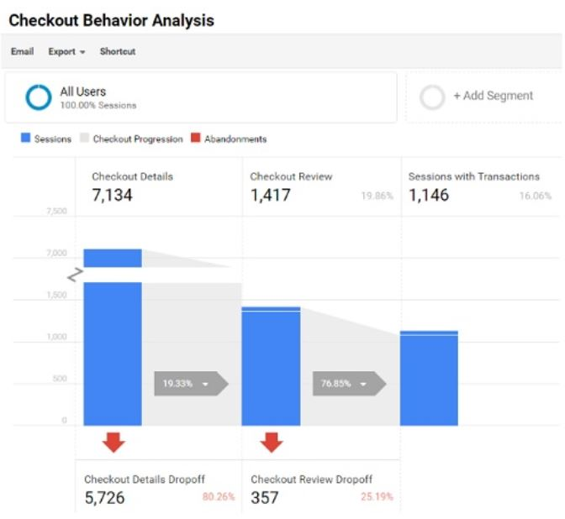

**Figure 1: Checkout behavior analysis using Google Analytics**

(https://www.optimizesmart.com/wp-content/uploads/2019/07/23-2.jpg)

There could also be data analysis related to the “segmented shopping behavior” for the assessment of the “user type”. Using Google Analytics properly the Checkout behaviors could also be tracked. Appropriate setups for the funnel steps should be applied in GA. The GTM should also be implemented for the checkout for the prop to properly assassinate. The analysis of “Product Performance” could also be possible with the appropriate use of GA.

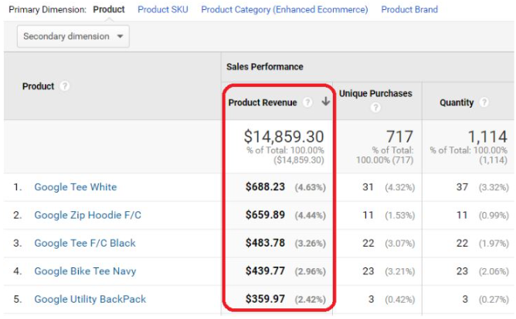

**Figure 2: Product performance analysis**

(Source: <https://www.optimizesmart.com>)

In the assessment, the product performance breakdown was conducted based on different ways that the company organizes its products on that site. Customer satisfaction would be evaluated for these products including refund amounts. After that, the “problem products” are required to be investigated. Using the pages of product details those problems for the products would be fixed.

## **Key audience attributes**

Using these Google Analytics the basic information of the visitor of the sales websites could be identified and used for the behavior assessment of these visitors. There could be a breakdown of the age and gender of the site visitors (Bag *et al.* 2021). The data of demographics are collected with the data of interest which are essential for assessing the online behaviors of users and purchases.

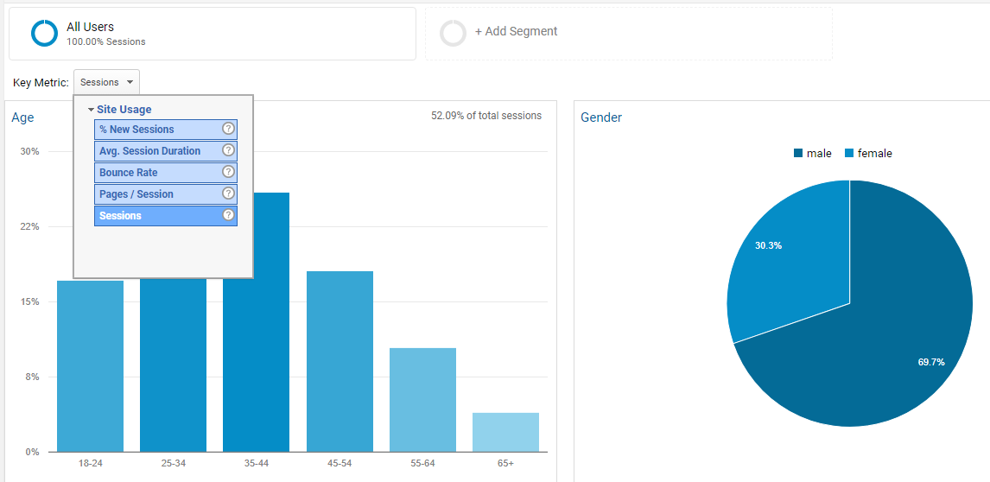

**Figure 3: Product performance analysis**

(https://online-metrics.com)

GA gets certain free information about different demographics of the visitors of the website. These data and related information are mainly collected from those people who have logged in to their Google accounts. There would also be “third-party cookies'' and additional app data for these assessments of the sales and related business.

# **How Power BI and Sales Data Can be used Alongside Google Analytics:**

The evaluation of the dataset, which is provided related to the sales websites could be possible if Power BI analytic software is used properly. The structural assessment of these datasets could be possible with the effective use of this analytical process. Different charts and relatable graphs could be used for the performance exploration of these business models. With the appropriate assessment of these statistics, the KPIs could be determined and assessed if Power BI is used properly (Tasanen, 2021). Appropriate tools and methods are required to be used for these assessments. For the extraction of necessary information these powerful tools could be used. The patterns which are hidden in a dataset could also be identified if these analytical tools are used properly. Python programs could also be used for the appropriate assessment of the integrated datasets related to business sales.

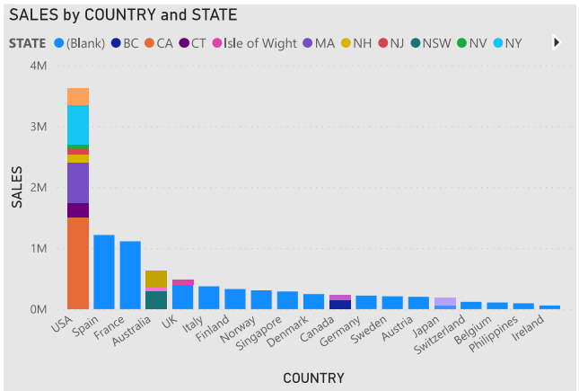

**Figure 4: Sales by Country and State**

(Source: Self-created in Power BI)

For performing required calculations these software applications are essential. With the appropriate use of this power BI software, proper visualization of the acquired data could be possible. These analytical visualizations are useful for the evaluation of the overall picture of these business models. T5he risks and the risk factors of these businesses could also be found if these analytical approaches are used properly. There are also different opportunities that could be found in this software is used as per the requirements (Han *et al.* 2021). Appropriate strategic planning for the development of these business models could be developed with the help of these assessments of Power BI. This information should be utilized for the effective assessment of the business conditions. These assessments are beneficial for businesses. If these businesses and sales sites could be integrated then that company could also be successful in their respective business market.

The details of each sale by the state could be assessed using Power BI “business intelligence” software. The improvement and decrement of sales in those states could be specified and analyzed in this process. With the implementation of appropriate strategic frameworks for sales these sales values in these states could be integrated or improved.

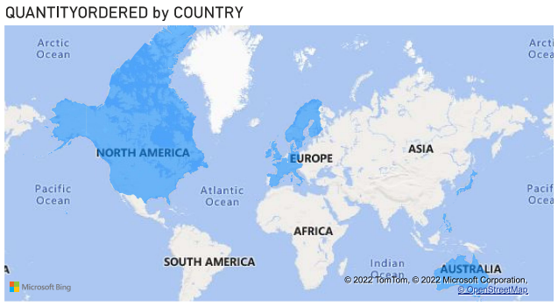

**Figure 5: Quantity ordered by each country**

(Source: Self-created in Power BI)

There could also be an effective use of appropriate visualization processes for assessing the sales for that company in every country. The growth of sales in those countries and their causes would be processed and evaluated for the further development of sales and businesses. There are also certain countries where the business of that company is critical. An appropriate assessment of the factors which are creating problems for the business should be conducted.

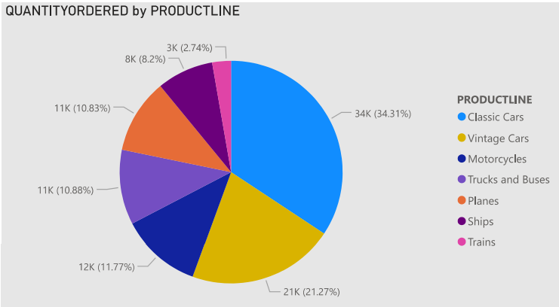

**Figure 6: Quantity ordered by Productline**

(Source: Self-created in Power BI)

These challenges and issues are required to be identified and removed for the further development of this business model. The number of certain products and total quantity could also be identified and assessed with the effective use of this Power BI software. Respective to a year after the analysis of the performances of these sales of these countries there could be the development of the business models (Mehmood *et al.* 2019). There could also be an effective use of the gauge charts with respect to the “quantity of ales” for each year.

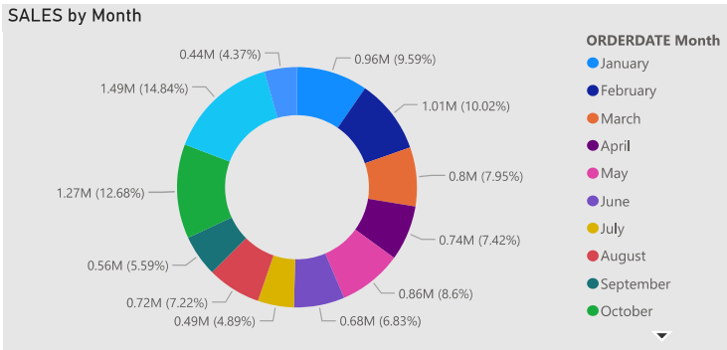

**Figure 7: Sales by Month**

(Source: Self-created in Power BI)

There could be different influencing factors of these businesses and related sales. These factors are generally dependent on the social, economical, and technological aspects of that company. Appropriate assessment and management of those factors are necessary for the further and appropriate development of these business models and sales websites. The quality of these sales models could be improved and applied for the betterment of the businesses of that company. Different challenges of different country markets could also be identified if these aspects of business or sales are analyzed properly. The evolution of technologies and digitalization could be possible for that company if these business analytic tools or software are used as per requirements.

# **Recommendations of Digital Technologies to be used by Reality Models in Years to Come**:

The development of the business of the Reality Model company could be possible if appropriate business assessment theories and technologies are used. There are also different digital marketing-related theories for the development of these businesses and sales. For the different aspects of business, there are requirements for appropriate assessment theories. For the betterment of the efficiency of the products and services, these analytical models and theories are applicable and effective. These business assessment and management tools are essential for the successful development of these business aspects. For the next few years, the company should use appropriate strategic frameworks for the development of its business and related sales. Effective project management tools would also be used for the proper development of these business structures (Attaran and Woods, 2019). The tracking tools of time could also be used for the proper assessment of the sales for these businesses of Reality Models. Different business-related activities could also be assessed and successfully completed if these technologies and business strategies are used appropriately. For the performance analysis of every member of that company, these analytical approaches would be effective. Different opportunities of these business models could also be identified and used for the market development of that company.

The business frameworks which are appropriate for decision-making should also be used for the betterment of the overall performance of that company. The additional marketing efforts required for the development of that company are required to be identified and applied. The appropriate analysis of the data related to the sales would be useful for the further development of their business strategies and models. The collection of information related to the consumers should be identified and gathered for the proper behavior assessments of them. The uses of digital technologies are essential to be used for the proper development of the technological aspects of that company. For the fulfillment of the customer requirements, these analytical tools and approaches are essential. Proper specification of the customer-related issues is important to be identified and analyzed for developing the business model. Respective “business-to-business” models should be used for the development of sales and sales-related services (Yang *et al.* 2020). The future growth of RealityModel company depends on these appropriate analyses of business factors and implications of business theories and models.

# **Conclusions**

The development of a business and related sales depends on the proper usage of analytical data and business theories. For the analysis of these businesses, there are different strategic approaches. For engaging with the customers proper “business-to-business” websites should be developed. There could be different stages of analysis for those business websites. For the assessment of customer behavior and product performance, there should be an effective use of Google Analytics. The analytical approaches of Google Analytics are essential for the overall understanding of the website and situation assessment of the business of a certain company. The collected data of business and sales of Reality Model company required to be assessed and visualized with the effective use of Power BI business analytics software. The related issues and opportunities of these business models could be identified and assessed for further development in this analytical process. Appropriate strategic frameworks for business and digital technologies should be used for the further development of that company in the future.

# **References**

**Journals:**

Attaran, M. and Woods, J., 2019. Cloud computing technology: improving small business performance using the Internet. *Journal of Small Business & Entrepreneurship*, *31*(6), pp.495-519.

Bag, S., Gupta, S., Kumar, A. and Sivarajah, U., 2021. An integrated artificial intelligence framework for knowledge creation and B2B marketing rational decision making for improving firm performance. *Industrial Marketing Management*, *92*, pp.178-189.

Brecht, P., Hendriks, D., Strobile, A., Hahn, C.H. and Wolff, I., 2020. Business Model Validation–How B2B Startups can use Business Experiments. In *ISPIM Conference Proceedings* (pp. 1-14). The International Society for Professional Innovation Management (ISPIM).

Cartwright, S., Liu, H. and Raddatz, C., 2021. Strategic use of social media within business-to-business (B2B) marketing: A systematic literature review. *Industrial Marketing Management*, *97*, pp.35-58.

Han, R., Lam, H.K., Zhan, Y., Wang, Y., Dwivedi, Y.K., and Tan, K.H., 2021. Artificial intelligence in business-to-business marketing: a bibliometric analysis of current research status, development, and future directions. *Industrial Management & Data Systems*.

Mehmood, T., Alzoubi, H.M. and Ahmed, G., 2019. Schumpeterian entrepreneurship theory: evolution and relevance. *Academy of Entrepreneurship Journal*, *25*(4).

Rao, R., 2020. *Social media usage in B2B firms* (Doctoral dissertation, Concordia University).

Reiter, M. and Miklosik, A., GOOGLE ANALYTICS BEST PRACTICES IN ONLINE BUSINESS.

Silva, S.C., Duarte, P.A.O. and Almeida, S.R., 2020. How companies evaluate the ROI of social media marketing programs: insights from B2B and B2C. *Journal of Business & Industrial Marketing*.

Sivarajah, U., Irani, Z., Gupta, S., and Mahroof, K., 2020. Role of big data and social media analytics for business to business sustainability: A participatory web context. *Industrial Marketing Management*, *86*, pp.163-179.

Tasanen, J., 2021. Digital Marketing in a Niche B2B Company.

Yang, Y., See-To, E.W. and Papagiannidis, S., 2020. You have not been archiving emails for no reason! Using big data analytics to cluster B2 B’s interest in products and services and link clusters to financial performance. *Industrial Marketing Management*, *86*, pp.16-29.